User Guide 55 Submissions to the Surveyor-General Victoria
Purpose of this User Guide
The purpose of this User Guide is to assist Applicant Contacts and the Surveyor-General Victoria (SGV) to submit and assess applications to the SGV in SPEAR.
Who should read this?
Primary audience: Applicant Contacts and Surveyor-General Victoria
Introduction
Applicant Contacts can create and submit the following application types to the SGV in SPEAR:
- Notice of Re-Establishment (RE)
- Plan of Crown Allotment (OP)

Once submitted, the SGV must assess the application and can request amendments of application documents through SPEAR. For Plan of Crown Allotment applications, the Surveyor-General (or delegate) will be required to certify the plan in SPEAR using a digital certificate.
55.1 Submit a Notice of Re-Establishment (RE)
To create and submit a Notice of Re-Establishment application, follow the steps in User Guide 1 - Creating a subdivision application in SPEAR and select the ‘Notice of Re-Establishment’ option.
Browse and attach the Notice of Re-Establishment document and enter the Surveyor’s reference number. Identify the parcel being re-established by completing one of the land description options.
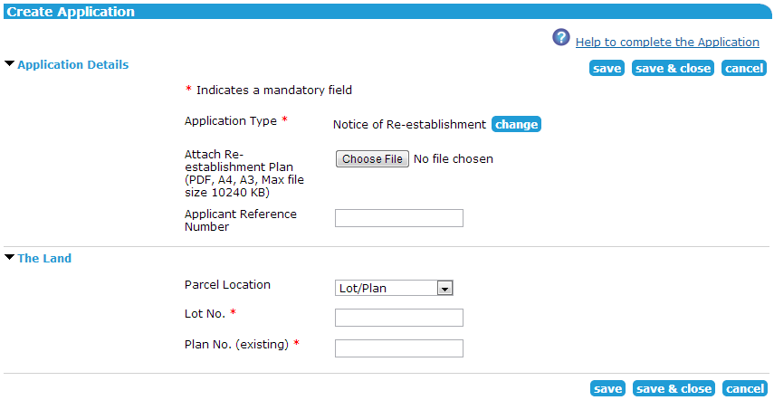

Once added, the Notice of Re-Establishment needs to be digitally signed and the application can be submitted to the SGV.
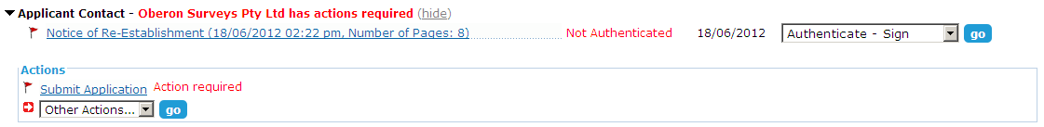

55.2 Submit a Plan of Crown Allotment (OP)
To create and submit a Plan of Crown Allotment application, follow the steps in User Guide 1 - Creating a subdivision application in SPEAR and select the ‘Plan of Crown Allotment’ option.
Indicate whether a Plan of Crown Allotment and/or a Title Plan form part of the application and who will be responsible for attaching the plans. The plan numbers can be defined here (if known) or left blank if the SGV will be allocating them.
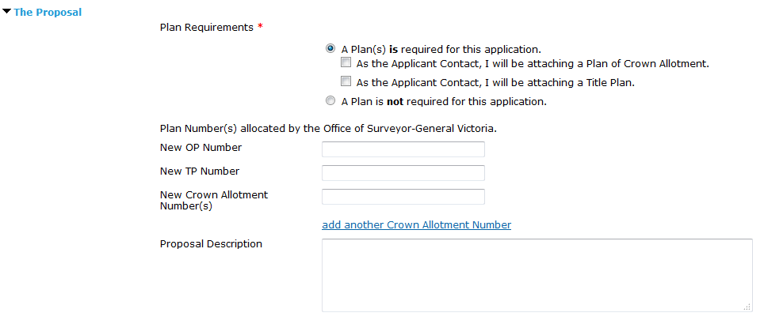

To provide client details, choose from a list of predefined clients or enter client details in the fields provided.
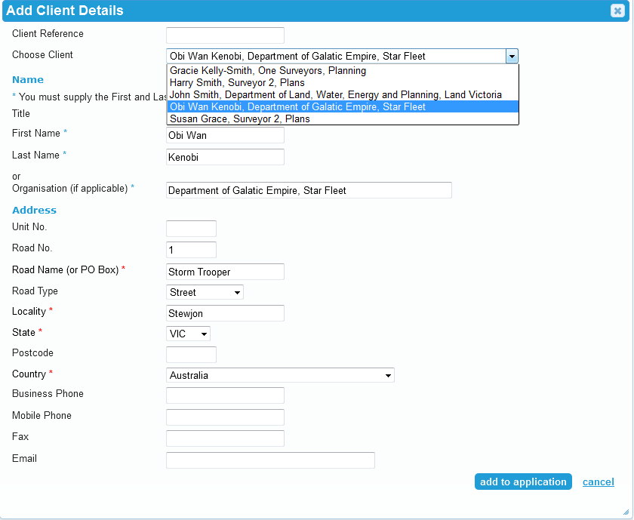

After completing the application form, the documents required for a Plan of Crown Allotment application may include those pictured below. Once the required documents have been attached and authenticated, the application can be submitted to the SGV.
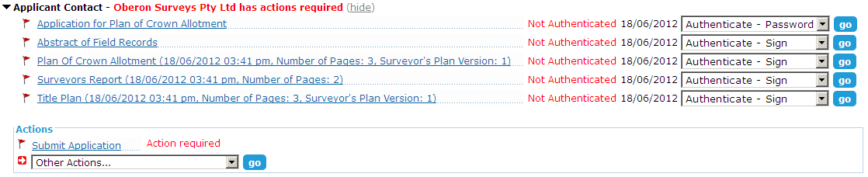

55.3 Assess an SGV application
The SGV must assess all applications received via SPEAR.
For PM Sketch Plan and Notice of Re-Establishment applications, the SGV can either accept the application or request amendments from the applicant. If the application is accepted, it will be moved to the Completed Applications list in SPEAR.
If amendments are required to the application documents, the SGV will need to specify these amendments from the Details screen.
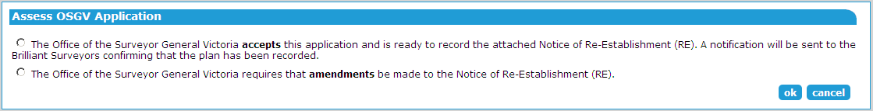

For Plan of Crown Allotment applications, the SGV can either accept or reject the application. If accepted, the Plan of Crown Allotment and/or Title Plan will need to be assessed and recommended for certification.
If rejected, the SGV will attach a reason for rejection. The Applicant Contact may then modify the application and re-submit it.
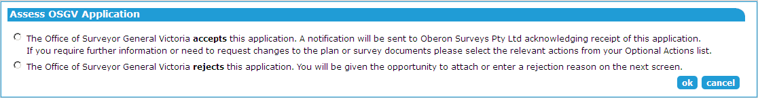

55.4 Request amendment to application documents
For PM and RE applications, where the SGV has indicated that amendments are required to application documents, the mandatory action ‘Request Amendment to Applicant Documents’ will appear.
Requesting amendments to Plan of Crown Allotment applications is optional (once the submission has been accepted by the SGV).
When requesting amendments to application documents, select which documents require amendment. Details of the required amendments will need to be entered or attached on the next screen. This will place a mandatory action on the Applicant Contact to supply new versions of the requested documents.
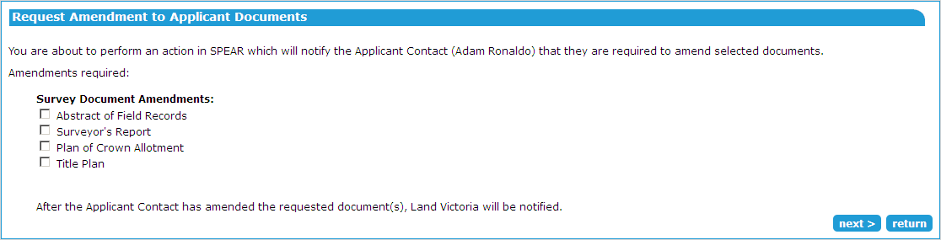

The SGV will be notified by email when the Applicant Contact has attached the amended documents and must assess the revised application.

55.5 Recommend a Plan of Crown Allotment and/or Title Plan for Certification
The SGV must complete the following actions for a Plan of Crown Allotment application before it can be certified by the Surveyor-General (or delegate):
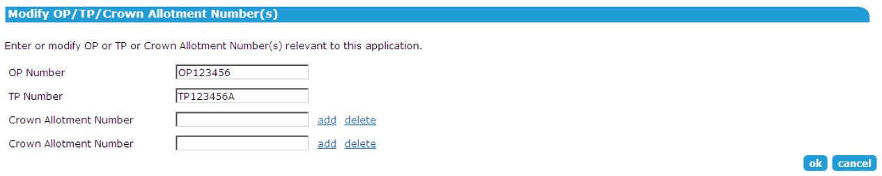
- Add the applicable OP, TP and Crown Allotment numbers. Alternatively, if they have already been supplied by the Applicant Contact, the numbers may be modified by the SGV, if required.

- Depending on the requirements of the application, provide a Plan of Crown Allotment and/or a Title Plan and Condition Sheets.

- Recommend the relevant plan/s for certification and select the Delegated Signing Officer from the drop-down list. Once authenticated, an email will be sent to the selected officer requesting them to certify the Plan of Crown Allotment and/or Title Plan.
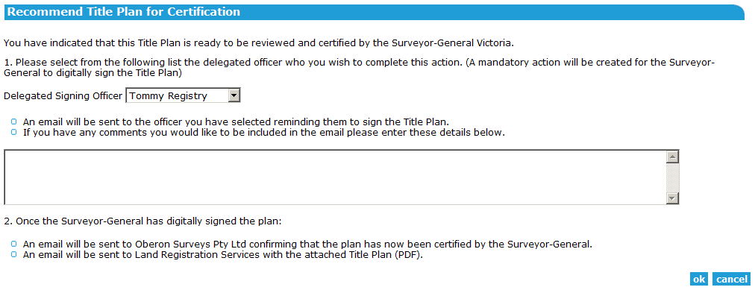

55.6 Certify a Plan of Crown Allotment and/or a Title Plan
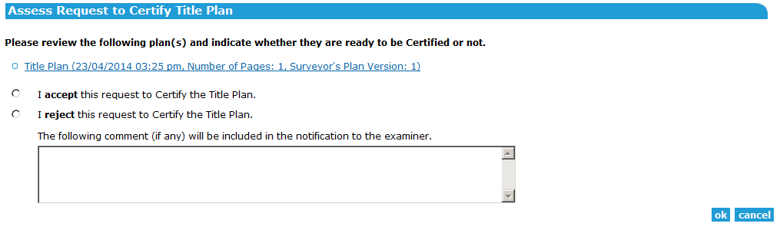
The Surveyor-General or (or delegate) must assess the request to certify a plan from the Details screen and select ‘accept’ or ‘reject’.

To certify the plan, the Surveyor-General (or delegate) must select the appropriate title from the drop-down list, click ‘sign’ and follow the digital signing prompts.
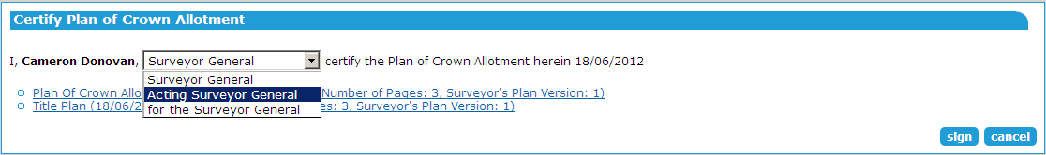

Once the required plans have been certified by the Surveyor-General (or delegate), the Land Use Victoria user can close the application by selecting ‘Close OSGV Application’ from the other actions drop-down list. This will move the application to the Completed Applications list.
In the event a Plan or Condition Sheet needs to be updated at a later date, the application can be re-opened by selecting ‘Open SGV Application’ from the other actions drop-down list. If the Conditions sheet is modified, once the document is authenticated it will create a new version of the Title Plan. When modifying a certified Title Plan, a mandatory action to recommend the plan for certification will appear.

Need more information?
Further information on this topic can be found by:
- Visiting the SPEAR website www.spear.land.vic.gov.au/SPEAR
- Contacting the SPEAR Service Desk on 9194 0612 or email spear.info@delwp.vic.gov.au
- Referring to User Guide 1 - Creating a subdivision application in SPEAR

